**BAMBAM**

**Technical and Installation Documentation**



**Document Revisions**

|  |  |  |
| --- | --- | --- |
| Date | Author | Description |
| 15-Apr-14 | T. Tedesco | New document for BAMBAM V .7 |
| 13-May-14 | T. Tedesco | Updated document for BAMBAM V.14. Added Configuration, Maintenance and Tools menus and ss. |
| 14-May-14 | T. Tedesco | Added Msg 13,16,20,25,26,32 screens. |

Introduction 4

ASRS/WMS Interface 4

SAP Interface N/A 4

Control System Interface N/A 4

BAMBAM User Interface 4

Client Installation 5

BAMBAM Program Installation 5

Removing BAMBAM from a PC 9

BAMBAM Configuration 10

BAMBAM ini File Configuration within the Installed Application Folder 10

BAMBAM.Ini File [Main] Section 10

BAMBAM.Ini File [Socket Communication] Section 10

BAMBAM.Ini File [RAID] Section 11

Operation 12

Login 12

Maintenance Menu Functions 12

Refresh Log 12

Tools Menu Functions 12

Send XML from File 13

Send XML from File (2) 13

XML Editor 13

Message 13, 16 Functions 14

Message 20, 26, 32, 25 Functions 15

# Introduction

The purpose of BAMBAM is to act as an emulator of a WMS (Warehouse Management System) for the ASRS (Automated Storage and Retrieval System) emulator. BAMBAM sends/receives XML messages via a TcpIp socket connection from RAID and acknowledges each message. Based upon the message received, BAMBAM may trigger a different XML message to be sent to RAID through a different TCP socket, or may send a response to the original message with a field filled in.

Details of the XML messaging can be found in the Red Prairie document “RTCIS XML RAI Messaging Interface Specification”.

BAMBAM is a Visual Basic 2005 application built to run on a Windows platform.

## ASRS/WMS Interface

RAID communicates to BAMBAM via an IP address and fixed port number as defined in Configuration, Socket Communication. BAMBAM provides an ini file setting to set the port number to receive on.

BAMBAM communicates to RAID via an IP address and fixed port number as defined in ini file settings that match RAID settings in Configuration, Socket Listening Ports.

The transmissions to/from RAID are terminated with a <CR> <LF><LF>. If BAMBAM receives a transmission ending with <CR> <LF><LF> it will transmit back to RAID an A with no terminating characters. If BAMBAM receives something other than a <CR> <LF><LF> at the end of transmission, it will transmit back to INTEGRATOR an N with no terminating characters.

## SAP Interface N/A

BAMBAM does not communicate directly with SAP and only processes files transmitted from SAP to a windows based file system.

## Control System Interface N/A

BAMBAM does not communicate directly with any control system.

## BAMBAM User Interface

The BAMBAM interface is very minimalistic. Eventually BAMBAM functionality will be incorporated into RTCIS V8.0. All data that BAMBAM processes is stored in log files. The user interface provides simple mechanisms to perform message 13,16,21, 24, 26, 32 as well as to display the current days log file.

# Client Installation

A Microsoft Windows setup package has been created to simplify the installation and the process for using the setup package appears later in this section. An eSupport package does not exist to install BAMBAM on SEWP pc’s.

Request program installation files can currently be requested from [stuckman.de@pg.com](mailto:stuckman.de@pg.com).

Requires an Oracle Client to be installed. Preferred Oracle Client is Oracle 8i Client available via eSupport.

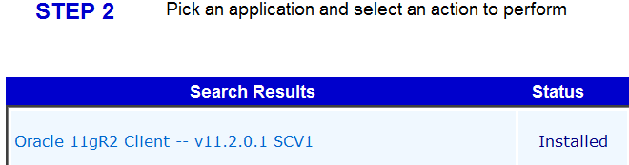

## BAMBAM Program Installation

Obtain access to the two files below on the installation pc either by network drive access or by copying the files to the local hard drive. The two files together form the BAMBAM installation package

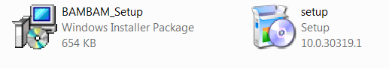

To install:

Close all applications

Double-click on setup.exe

The following message will appear then disappear:

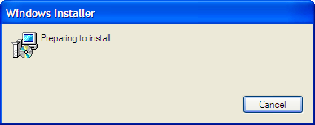

The following screen will then be presented:

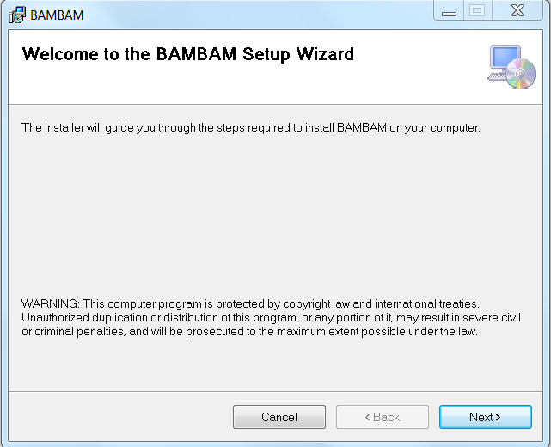

Select Next

The following screen will be presented:

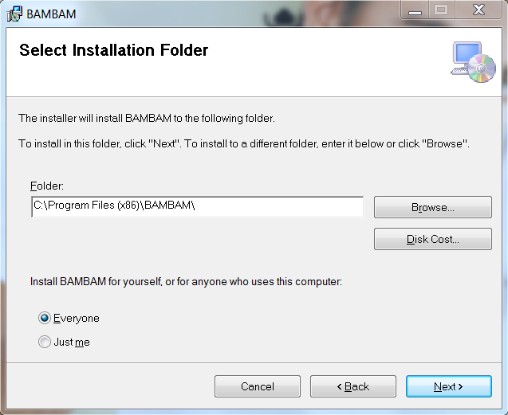

Change to Everyone if installing BAMBAM on a shared workstation.

The program can be installed in any folder, but the preference is to leave it

at the default of C:\Program Files (x86)\BAMBAM\.

The following screen will be presented after selecting Next:

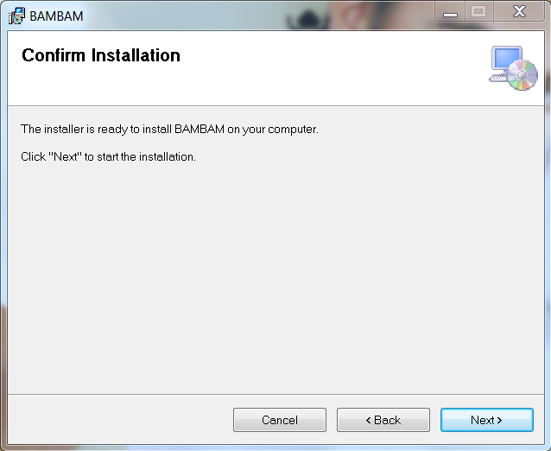

Select Next

The following screens will display:

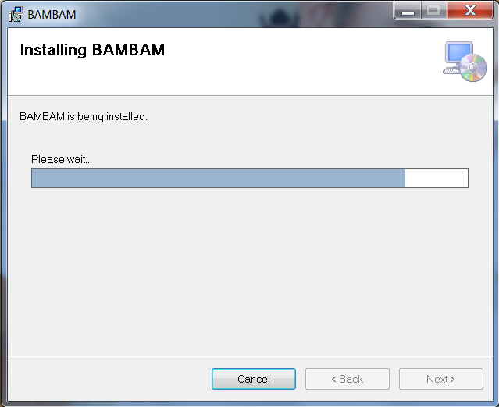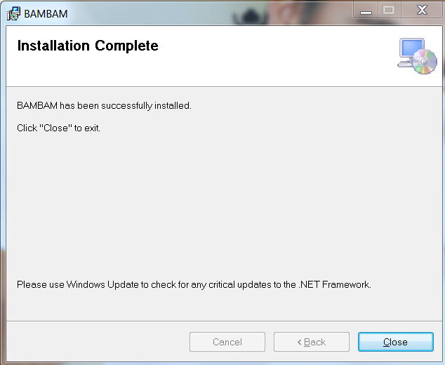

Select close

If the Oracle8i Client needed to be installed, the pc should be rebooted if has not been rebooted after the Oracle product was installed.

BAMBAM Program Version Update

This step needs to occur after initial installation and anytime a new application version is made available.

Once BAMBAM is installed. the setup.exe process can not be used again until BAMBAM is first uninstalled. Generally program updates are achieved by simply placing a new BAMBAM.exe into c:\program files (x86)\BAMBAM\ and replacing the existing BAMBAM.exe

The program version of BAMBAM can be found on the BAMBAM Menu bar in the upper left hand corner of the screen:

Example Screen Shots:

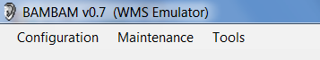

## Removing BAMBAM from a PC

From the pc’s Control Panel, Select “Add or Remove Programs”

Find BAMBAM under Currently Installed Programs then remove it just like any other program

# BAMBAM Configuration

## BAMBAM ini File Configuration within the Installed Application Folder

BAMBAM has flexibility built into its setup through the use of an ini file that configures how BAMBAM should run on each pc it is installed on . Changes are made directly made to the ini files. The ini file must reside in the C:\ProgramData\BAMBAM folder. The installation folder is typically C:\Program Files(x86)\BAMBAM\

After launching BAMBAM.exe (from desktop shortcut), access the visual configuration screen from the Configuration Main menu

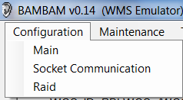

### BAMBAM.Ini File [Main] Section

Sample Settings:

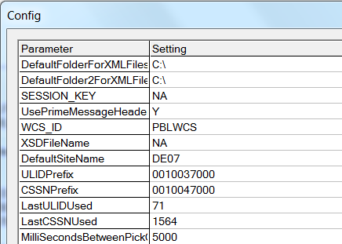

### BAMBAM.Ini File [Socket Communication] Section

Sample Setting:

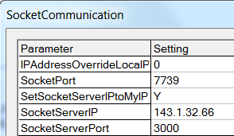

Set IPAddressOverrideLocalPC= 0 for BAMBAM to automatically read the IP address from the pc. This IP address is what is used for Socket Listening Services. When multiple IP addresses exist, this setting may need to be used to assure that the “right” IP address is utilized. This setting is also made available for configuration on the initial login screen.

Set SocketPort to the agreed upon ListenPort1 that is set in RAID.

Set SocketServerIPtoMyIP= to either Y or N. When set to Y, RAID will automatically set SocketServerIP= to the pc’s IP address. This is useful when BAMBAM is talking to an ASRS emulator such as RAID that is running on the same PC.

Set SocketServerIP= to the IP address of the RAID listener (see above if both emulators are on same pc).

Set SocketServerPort= to the port of the RAID listener.

### BAMBAM.Ini File [RAID] Section

Sample Setting:

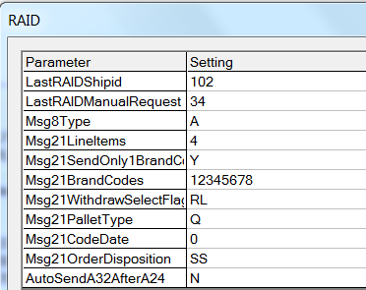

LastRAIDShipid is the shipid of the last shipment sent to the RAID.

LastRAIDManualRequest is the request # of the last manual withdraw request.

Msg8Type determines whether an 8A, 8M, 8C etc. will be sent to RAID.

All of the Msg21 items determine what will be sent to RAID when a shipment is dropped (bran code, quality status, pallet type, etc.)

AutoSendA32AfterA24 determines whether a slot signon will automatically be sent after an A24 for a shipment.

# Operation

## Login

There is not a login when BAMBAM is launched. BAMBAM connects to RAID, not to an RTCIS database.

## Maintenance Menu Functions

The following functions are available for selection under the maintenance menu:



### Refresh Log

Refresh Log performs the same function as the Refresh Log button the screen. Auto Refresh Log can be checked to ensure that the display is up to date in showing all communication between BAMBAM and RAID.

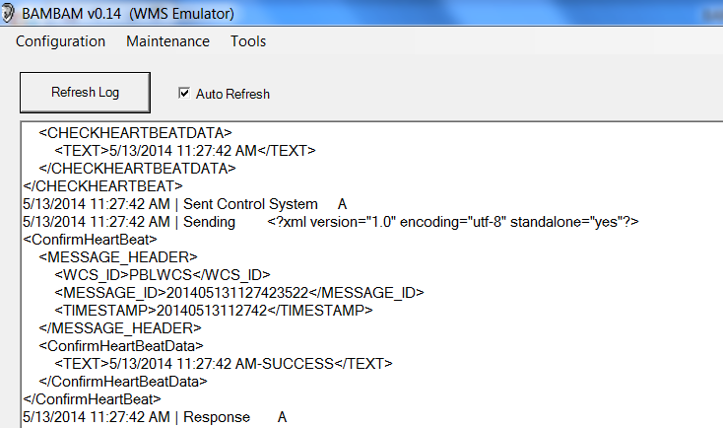

## Tools Menu Functions

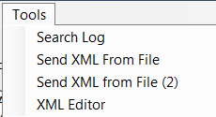

### Send XML from File

This option allows the user to send any XML message to RAID.

The default path for Send XML from File is set by the parameter DefaultFolderForXMLFiles in the Configuration Main screen. Enter the filename after the path. For repeated tests of the same message, DefaultFolderForXMLFiles could be set to include the file name.

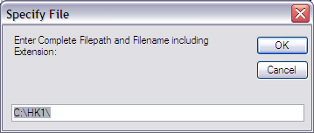

### Send XML from File (2)

This option allows the user to send any XML message to RAID.

The default path for Send XML from File is set by the parameter DefaultFolderForXMLFiles in the Configuration Main screen. Enter the filename after the path. For repeated tests of the same message, DefaultFolderForXMLFiles could be set to include the file name.



### XML Editor

BAMBAM stores into memory the last XML message sent. When BAMBAM is closed the last XML message is written to disk as LastXMLSent.txt into the ProgramData/BAMBAM folder .

When the XML editor is launched, the text display will first check memory then disk if necessary to display the last XML message sent.

The text display does not update as messages are sent, only when the XML Editor form is launched, or when “Get Last XML Sent” is selected.

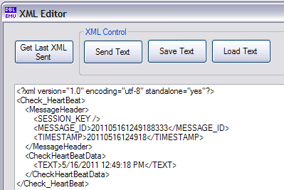

The text display can be edited by the user and then sent via sockets to the remote system by selecting “Send Text”

The text display can be saved and reloaded at a later time via the “Save Text” and “Load Text” buttons:

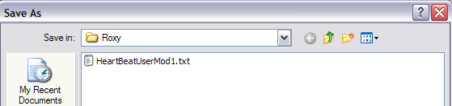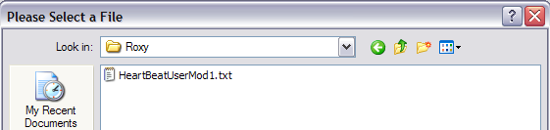

## Message 13, 16 Functions

Sample Setting:

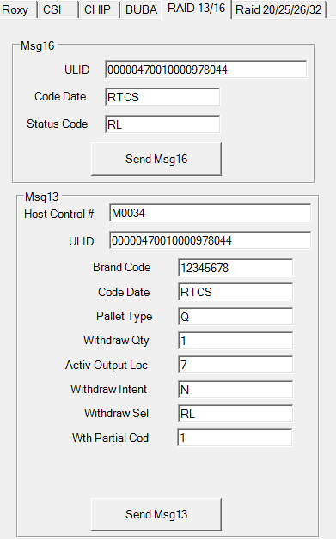

This screen is used to change the quality status of a ulid(s) in RAID (Msg 16). It is also used to do a manual withdraw request to RAID, either by code date or ulid (Msg 13).

## Message 20, 26, 32, 25 Functions

Sample Setting:

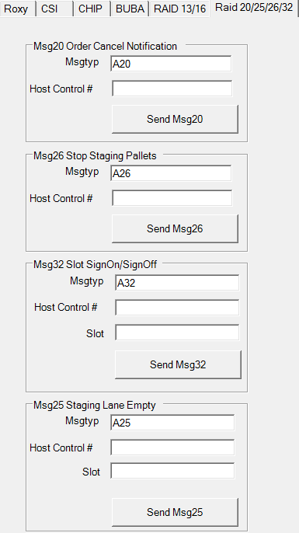

This screen is used to cancel a shipment in RAID (Msg 20). It is also used to send a stop staging a shipment message to RAID (Msg 26). A slot signon (A32), signoff (D32), and unstage (U32) message to RAID is also sent from this screen. D32 and U32 require slot only.

A message used in London’s MSX system is also sent from this screen to indicate a staging lane is empty (Msg 25).